** PRESS RELEASE FROM MARRIAGE FOUNDATION / RHODA HARDIE PR **
Embargo 0001 2nd January 2020
Divorce rates are falling across Europe – and the UK is leading the way
- The first working Monday of the New Year – Monday 6 January in 2020 – is often known as ‘Divorce Day’, when lawyers typically see a spike in couples considering divorce.
- But new research by Marriage Foundation shows divorce rates in the first 15 years of marriage are falling across Europe – and the UK is leading the way, with the biggest fall in divorce rates over the last 25 years.
- During the earliest five years of marriage, divorce rates have now fallen in 15 of the 20 countries surveyed.
- The analysis uses data from Eurostat to build a far more accurate assessment of divorce rates than has previously been available.
The Christmas holidays is a special time for many families as they spend quality time together. However, for some couples, the intensity of spending so long with each other highlights the tensions in their relationship, leading a considerable number of people to make enquiries about divorce when the working year begins again in January. This has led the first working Monday of January – which falls on 6 January in 2020 – to be known as ‘Divorce Day’.
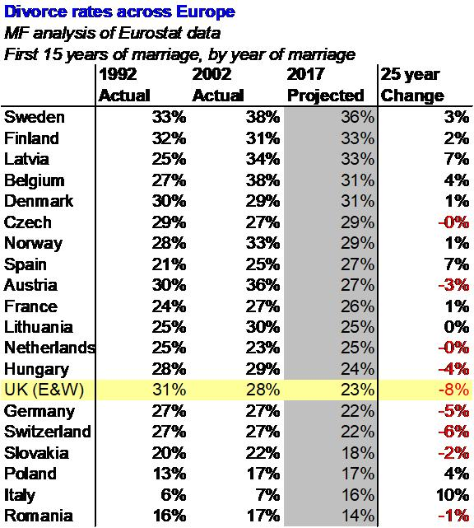
However, a new report released by Marriage Foundation, using data from Eurostat, shows that divorce rates in Europe are continuing to fall – with the UK leading the way. UK couples marrying in 1992 had an actual divorce rate of 30.7% during the first 15 years of their marriage - the 3rd highest rate out of the 20 countries surveyed. A decade later, for UK couples marrying in 2002, this rate had fallen to 28.1%. For UK couples who married in 2017, the projected divorce rate is 22.5%.
Interestingly, divorce rates are overall higher in Scandinavia and Northern Europe (with Sweden, Finland, Latvia, Belgium and Denmark heading up the table) whereas Catholic countries generally have the lowest divorce rates (with the exception of Spain). Slovakia, Poland, Italy and Romania show the lowest divorce rates, with Romania showing a projected divorce rate of just 14% for couples marrying in 2017 – Sweden has the highest projected divorce rate of 36%.
Harry Benson, Research Director for Marriage Foundation, commented:
‘Our analysis provides the most accurate picture of European divorce rates ever seen. We have long claimed that lower divorce rates in the UK are due to the relaxation of social pressure to marry. The result is that those who do marry are more committed and hence more likely to stay together. We are just beginning to see this trend ripple across Europe in the earliest years of marriage. But over the first fifteen years of marriage, Britain clearly leads Europe.’
Sir Paul Coleridge, founder of Marriage Foundation and former high court judge, added:
‘To be in gold medal position in the European race to reduce divorce rates is an accolade for which we can, as a nation, justifiably be proud. It is consistent with all the recent statistical data showing that marriages are being undertaken nowadays with a degree of serious commitment not seen for decades. By comparison with their parents, couples are marrying later, more thoughtfully and thus more enduringly. Hopefully they are also taking notice of the constant stream of data showing the qualitative advantages to married relationships. Now the challenge is to persuade those who do not marry that their informal cohabiting relationships are inherently far less stable or beneficial, which is not at all good for them and disastrous for their children.’
Full report available from Harry Benson (07515 699187 / harry.benson@virgin.net) or Rhoda Hardie (0781 542 7111 / Rhoda.hardie.pr@gmail.com).
[ends]

Notes to editors
To discuss interviews or request a comment, please contact Harry Benson on 07515 699187 / harry.benson@virgin.net or Rhoda Hardie on 0781 542 7111 / Rhoda.hardie.pr@gmail.com.
About Marriage Foundation
Marriage Foundation was founded in 2012 by Sir Paul Coleridge, a High Court judge who was moved by his personal experience in 40 years as a barrister and judge specialising in family law. The think tank seeks to improve public understanding of marriage and to reduce the numbers of people drawn into the family justice system – some 500,000 children and adults each year. It has established itself as a leading voice on marriage issues in the UK.
A source of statistics on marriage, cohabitation, commitment, divorce and family breakdown can be found on the Marriage Foundation website: http://marriagefoundation.org.uk/

